Disposition Code by Phone Code
Last updated on February 27, 2012

Note: To use the disposition code by phone code you must be on RMEX 2.2 or higher for this to work.

Description of Feature:
Disposition code by phone code allows you to enter map disposition codes to different smart codes based on the phone code dialled regardless of which phone number field was dialled.
Disposition code by phone code must be set up in order to use Calling Multiple Numbers by Campaign feature.

RMEX Instruction:
In RMEX, go to the Itel Options Menu.
Take option 6. Other phone number options.
Take option 1. Other phones system control file.
Enter the phone code you wish to set up.

Take Option F10 to Create disposition codes.
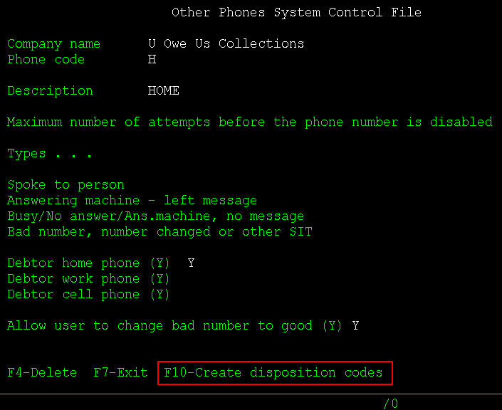

You will now see your phone code in the disposition by phone code table that will appear.
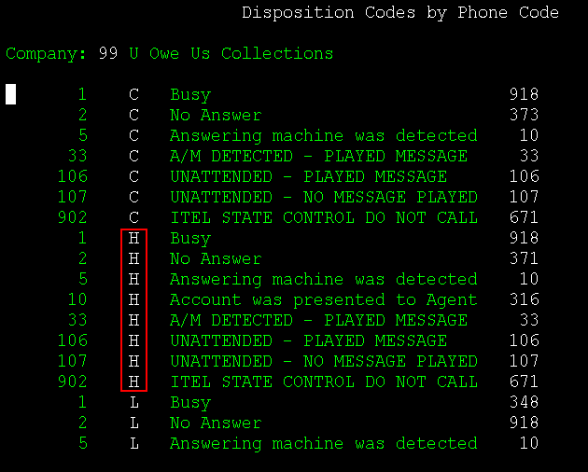
Note: You can hit F11 to resort this list to group by phone code.

Enter a "1" next to the item you wish to edit.
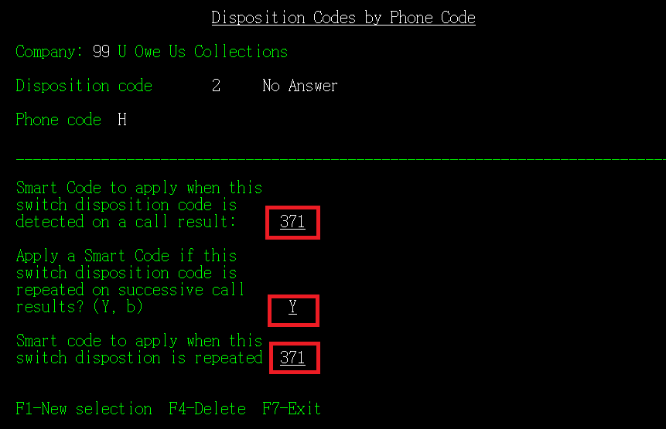
Make sure the fields in red are filed out.

Disposition Code: Is informational only.
Smart Code to apply when this switch disposition code is detected on a call result: Enter the Smart code to be applied when the disposition code is returned.
Apply a Smart Code if this switch disposition code is repeated on successive call results? (Y, b): Enter "Y".
Smart Code to apply when switch disposition is repeated: Enter the Smart code to be applied when the second, third calls are made. This smart code will only apply if the same disposition code is applied the same day only.

You can also view/edit disposition codes by phone code by going to the following screen.

In RMEX, go to the Itel Options Menu.
Take option 16. I-Tel System Control options.
Take option 3. Disposition codes.
Hit F10 for " F10-Disposition codes by phone code".
This will bring up the Disposition code by Phone code screen.

*Note: In order to see your phone code in disposition code by phone code screen you must run the "Create disposition code" option on page 1 of this instruction guide.

