|  |
| --- |
| **Using FTP To  Move Files To And From iSeries** |
|  |

# 

# **Turn Your PC in an FTP Server: For Transferring Files FROM the ISeries to A PC**

**This document is detailed enough for a person who has limited knowledge in FTP server software and how networks work, however please contact your technical personnel to assist you in this process if needed. Quantrax is not responsible and does not support this software or your networks, but we have tested it and found it a valuable tool.**

If you have an FTP Server in your office that you can access FROM your iSeries you have the ability to use either the FTP module OR if you have access to a command line from the iSeries to move files back and forth. But if you do not have an FTP Server in your office you can turn your PC into an FTP Server.

Below is a demonstration of how to use a program running on my PC called “FileZilla Server”, an Open Source and free server. Keep in mind this is the FileZilla SERVER software, NOT the popular FileZilla FTP client software.

**NOTE**: We DO NOT support nor answer questions about FileZilla. This is for demonstration purposes ONLY, there are many fine FTP Server programs you can choose from.

This document is broken down into three sections

1. **FileZilla FTP Server Setup:** How to install the FileZilla software
2. **STATIC IP Address:** When setting up your FTP Server on your PC or Server, you will want that computer to have a “Static IP Address”. We will discuss this in more details at the end of this document.
3. **RMEx FTP Module**: Instructions for using the RMEx FTP Module are listed below. **IMPORTANT NOTE:** If you are going to use the RMEx FTP Module to access, and transfer files, to and from the FileZilla FTP Server (Or any other FTP server) MAKE SURE, on the FTP Module, you change the **“FTP Address”** field and “**Remote Library|Directory”** field to match the settings you have for FileZilla.
4. For this demonstration I will be creating a folder off my C:\ drive called FTP. When I am done the example files will be in C:\FTP.

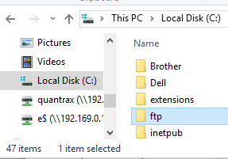

1. Now you will need to download your FTP Server software and install it. In this case from <https://filezilla-project.org>
2. Note once again we are downloading the Server NOT the client software. I choose to install FileZilla just using the Defaults.

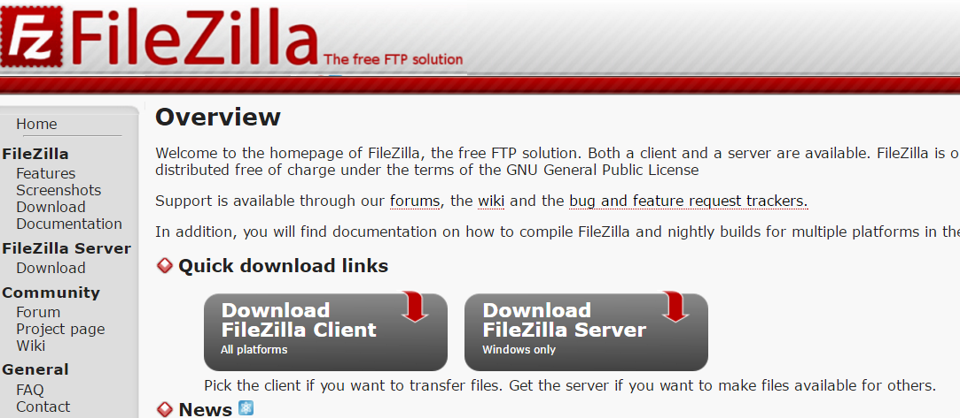

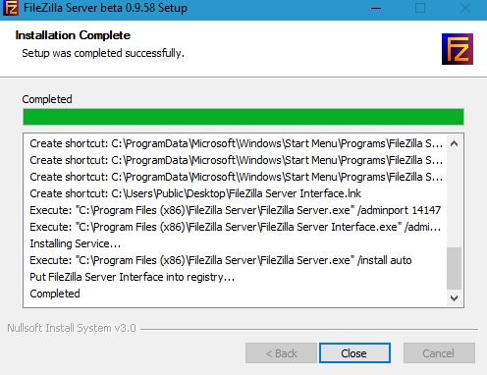

1. At this point I added a *Password* so not just anyone can control my FTP Server. Otherwise I left everything as default and clicked **Connect**.

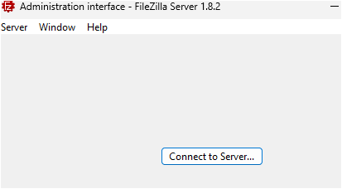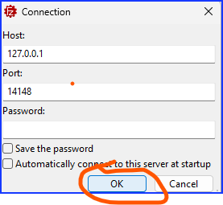

NOTE: Since I am running this server in my office (locally on a secure network) I ignore any TLS warnings if they appear.

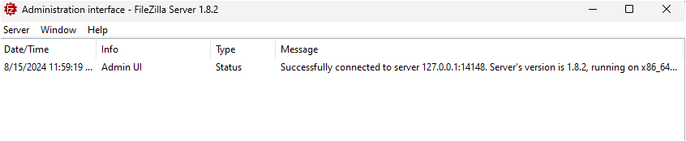

1. Next Adding Users: Click **Server** > **Configure**

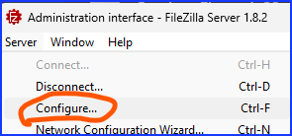

1. Next, click **Users> “Add” button**, insert a *user name* then click **OK**.

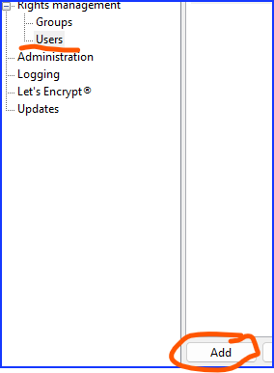

Then give the user a login Name

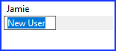

1. Click “Require a password to log in”, and then fill in the password.

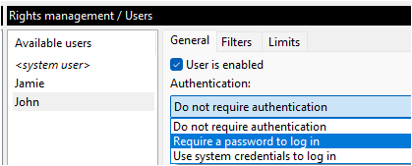

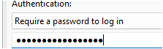

**NOTE:** This user name and password will be used by your FTP client, so please make a note of it.

1. Next click **Add** so we can choose the folder to be used and give the permission for “Read + Write” etc.

For the “Mount Points”

Virtual Path = **“ / “** (Forward Slash) nothing else is needed here for a basic setup

Native Path = The Directory where the files will be stored on your hard drive. C:\FTP is the example here. You will need to type the path in.

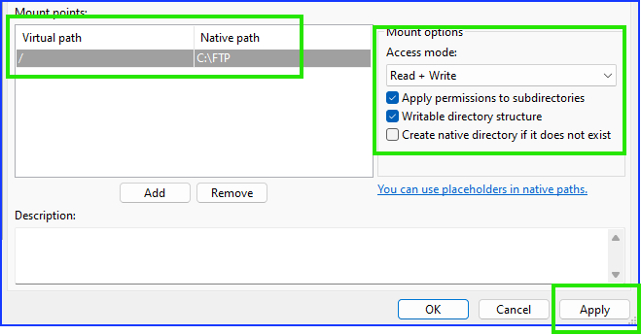

1. When all is filled in click **Apply**

1. You now have an FTP Server running on this PC. When you login using your FTP client software all the files will be *moved* to and from C:\FTP.

IF you have issues with logging in make sure you the “Server listners” are setup with these **protocols.**

Change nothing else on this page unless you understand the options.

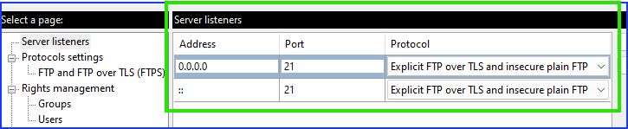

# **Accessing your FileZilla FTP Server on your computer and the computers IP Address**

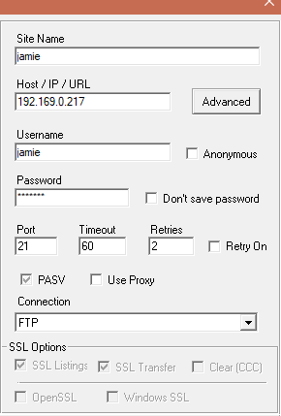With the FileZilla server running on your computer you can now use almost any FTP client software you have used in the past such as the RMEx FTP Module, CoreFTP, DOS prompt, etc. To do this, you will just need to the IP Address of the computer running the FileZilla as the “FTP Site Address”

In this example using CoreFTP the “Host/IP/URL” is the same as the computer running the FileZilla FTP Server.

**Finding your IP Address and using a “Static” IP address**

Since you will be using your computers IP address, you may want to give that computer a permeant IP address. We do this by giving a computer a “Static” IP address. If you do not use a static IP address, there is a chance your computer could change its IP address after a reboot, or being shut down for a long time, and if the IP address changes, any automatic FTP processes you may have in place will fail.

**To See and Set a Static IP Address in Windows 7, 8, or 10**

To change the computer’s IP address in Windows, you’ll need to open the “Network Connections” window. Hit Windows+R, type “ncpa.cpl” into the Run box, and then hit Enter.

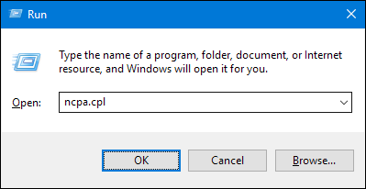

In the “Network Connections” window, right-click the adapter for which you want to set a static IP address, and then select “Status”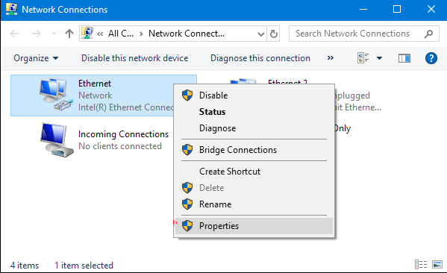

And then click “Details”

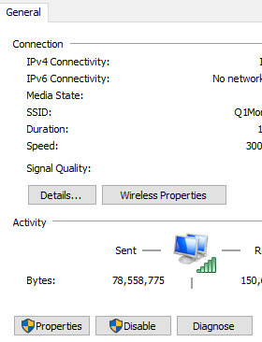

**If it says “DHCP Enabled” says “No”** **Stop here you have a static IP address**. **You will use the IP Address in the ”IPv4 Address field” as your FTP Server Address**. If it says “Yes” You will continue on. BUT…

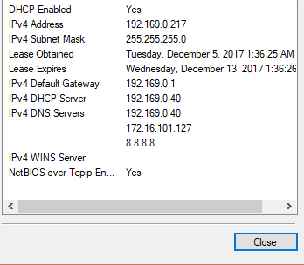

Information needed for the static IP Address:

* IPv4 Address
* IPv4 Subnet Mask
* IPv4 Default Gateway
* IPv4 DNS Servers

Since the field “DHCP Enabled” has a YES we are going to write down the information in this box and use it to create a static IP address.



Once you have gathered the needed information. Click the “Close” button.

Now back in the “Network Connections” window, right-click the adapter for which you want to set a static IP address, and then select the “Properties” command.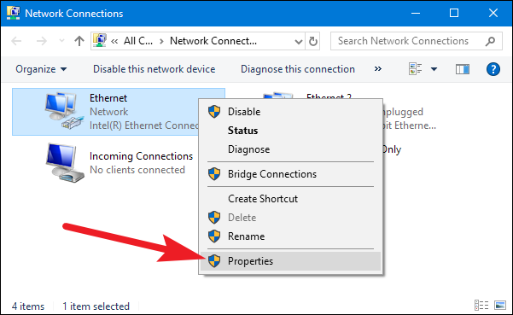

In the properties window for the adapter, select “Internet Protocol Version 4 (TCP/IPv4)” and then click the “Properties” button.

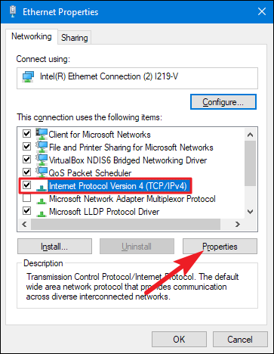

Select the “Use the following IP address” option, and then type in the IP address, subnet mask, and default gateway that corresponds that you wrote down. Next, type in your preferred and alternate DNS server addresses. Finally, select the “Validate settings upon exit” option so that Windows immediately checks your new IP address and corresponding information to ensure that it works. When you’re ready, click the “OK” button.

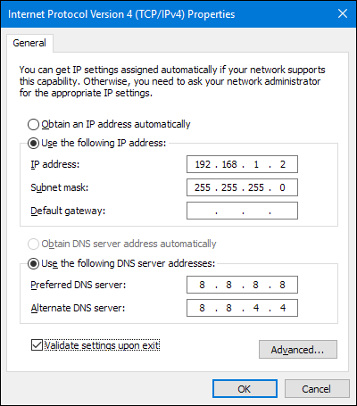

Information needed for the static IP Address:

* IPv4 Address
* IPv4 Subnet Mask
* IPv4 Default Gateway
* IPv4 DNS Servers

(Note: If you have additional DNS servers, just click on “Advanced” to add them)

The IP address entered here (ex: 192.168.1.2) will be your FTP Server address.

When finished click on “OK” to close out of the network adapter’s properties window.

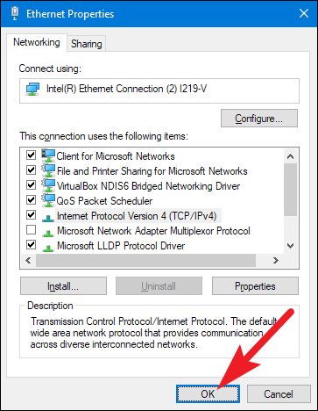

Windows automatically runs network diagnostics to verify that the connection is good. If there are problems, Windows will give you the option of running the Network troubleshooting wizard. However, if you do run into trouble, the wizard likely won’t do you too much good. It’s better to check that your settings are valid and try again.

# 

# **Using The RMEX FTP Module**

The FTP Job processing module allows you to schedule the transferring of files between the AS400 and your FTP site automatically. Once set up, the processing will occur on the date and time entered.

**Note:** If you power down your system, run an IPL, loose power, etc. you will need to reactivate the schedules (see bottom of doc for instructions)

1. Before creating your first FTP job, Quantrax will need to activate the FTP Module. If you get an error please contact Quantrax.
2. From **System Control menu 4** > **1-FTP Job Processing**, you can:

* Press **F6** - **Create a new job**
* Type **2** - **Change an existing job**
* Type **3** - **Copy an existing Job**
* Type **4** - **Delete an existing Job**

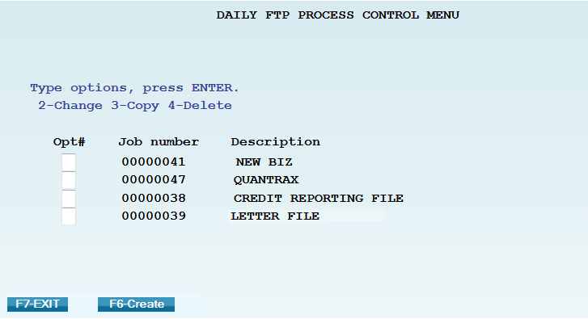

**NOTE:** Once you have Jobs created it is more efficient to just copy an existing one and make the needed changes rather than creating a new one each time.

## **Daily FTP Process Control Menu – Glossary Of Fields**

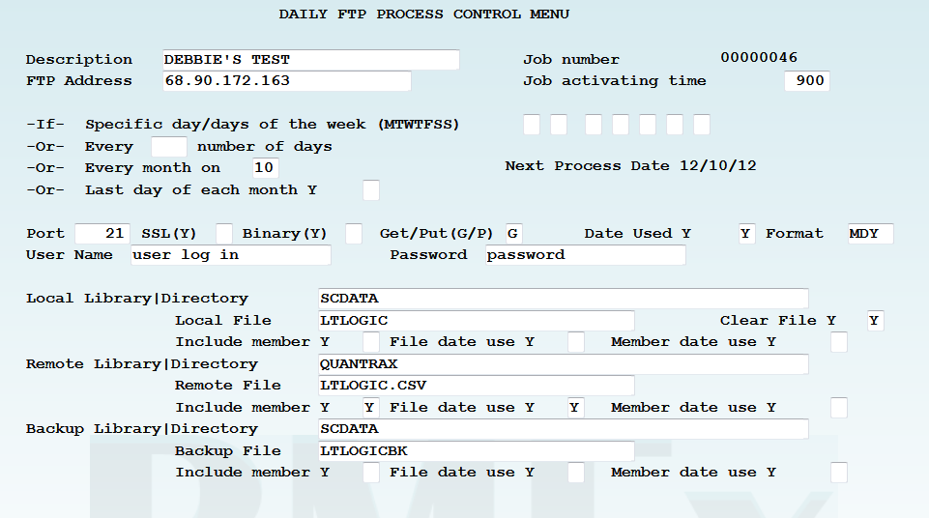

**Note: Options above in red MUST be changed if you start using a different FTP Server (Such as FileZilla)**

* **Description** – Name of the job
* **Job number** – Assigned by RMEx
* **FTP address** – The FTP address associated with your FTP site.
* **Job activating time** – Time of day the job should run (military time)
* **-If- Specific day/days of the week (MTWTFSS)** – Enter a “Y” in the associated day of the week field
  + **-Or- Every __ number of days** – every “x” number of days (ex. Run every 10 days)
  + **-Or- Every month on __** - A specific day of the month (ex. Run on the 10th of each month)
  + **-Or- Last day of each month Y _** - “Y” if you want it to run on the last day of the month
* **Port** – The port used to connect to the FTP site (default is 21 as that is the most commonly used)
* **SSL** - Secure Socket Layer (currently not available)
* **Binary** – If the file needs to be transmitted as binary (mainly used for transmitting programs), enter a “Y”
* **Get/Put** – If you are moving a file from the FTP site to the AS400, enter “G” = get. If you are moving a file from the AS400 to the FTP site, enter “P” = put
* **Date Used** – If you are going to be using a date within the naming convention, enter a “Y”
* **Format** - If you are going to be using a date within the naming convention, enter the format to be used. Ex. MDCY, MDY, YMD, etc.
* **User name** – Enter the User name to log into the FTP site
* **Password** – Enter the Password for the User name

**NOTES:** Job activating time and a day/date schedule are required. If you are going to be manually processing every day, to prevent auto processing you can enter 999 in the field **-Or- Every __ number of days**

* **Local = AS400 (RMEx)**
  + **Local Library|Directory** – Enter the library name on the AS400 where the file should either be put to or gotten from (example below = SCDATA)
  + **Local File** – Enter the valid file name that should exist on the AS400 (example below = LTLOGIC)
  + **Clear file** – Enter a “Y” if you want to clear the existing AS400 file once transmission is complete
  + **Include member** – Enter a “Y” ONLY if the AS400 member name is different from the file name
  + **File date use** – Enter a “Y” if the FTP module should associate a date within the name of the AS400 file
  + **Member date use** – See File date use above. This field is rarely used, it is only used if there is a date associated with the member name

* **Remote = FTP site**
  + **Remote Library|Directory** - Enter the directory (folder) name on the FTP site where the file should either be put to or gotten from (example below = QUANTRAX)
  + **Remote File** - Enter the valid file name that should exist on the FTP site (example below = LTLOGIC.CSV)
  + **Include member** – Always enter a “Y” as this associates the file extension (.txt, .csv, etc.)
  + **File date use** – Enter a “Y” if the FTP module should associate a date within the name of the FTP file (date appears before the extension)
  + **Member date use** – This field is rarely used. Enter a “Y” if the FTP module should associate a date within the name of the FTP file (date appears after the extension)
* **Backup = AS400 (RMEx)**
  + **Backup Library|Directory – The library name on the AS400 where the backup file should be created (example below = SCDATA)**
  + **Backup File - Enter the valid backup file name that should be created on the AS400 (example below = LTLOGICBK)**
  + **Include member – Enter a “Y” ONLY if the AS400 member name is different from the file name**
  + **File date use – Enter a “Y” if the FTP module should associate a date within the name of the AS400 file**
  + **Member date use – See File date use above. This field is rarely used, it is only used if there is a date associated with the member name**

**NOTE:** All file names MUST follow standard file naming conventions to be considered valid.

Ex. AS400 file names can only be a max of 10 characters and cannot begin with a Q, keyboard character or number. FTP site file names cannot have certain keyboard characters in them.

**NOTE:** When a date is used in the file name – the date in the file name must be the exact date as the file that is being transmitted.

**NOTE:** Files are only transferred between the iSeries and your main FTP directory. FTP Sub folders cannot be used at this time.

**F10-Process Immediately** = Runs the process immediately instead of at a scheduled time.

* Can be used to process 1 time files or files where the name changes from time to time.
* If there is a date extension associated with either file, you will be presented with this additional screen:

**NOTE**: You must manually enter the local and remote file names, including any date and member/extension associated.

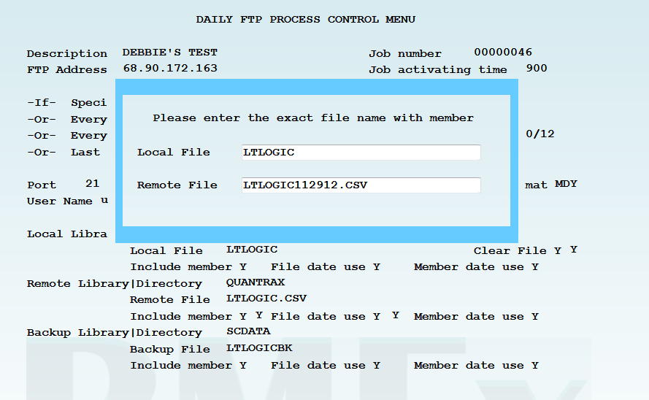

**NOTE:** If there is no date extension associated with either file, you will not be prompted to re-enter the file names.

**NOTE:** If setting up a Process Immediately for the first time you must F12-Update before using the F10-Process Immediately feature.

**F8-Log** = Specifics regarding the success or failure of the last time this job was processed

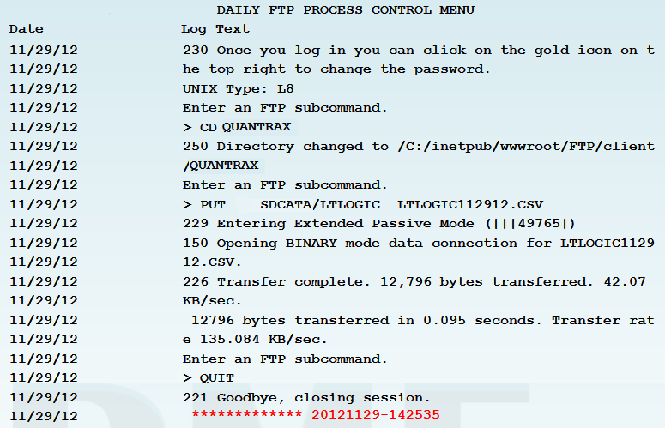

## **Troubleshooting:**

If your AS400 takes a power hit the FTP Job processes will need to be reset.

Go into each job:

1. Use **2-change**
2. Confirm day and time
3. Press **F12**
4. This will reset the schedule for that FTP job

**NOTE:** Most FTP sites have security settings that prevent hackers from accessing the site. One of these features blocks any IP address that is perceived to be attacking it. To help prevent this blocking, we have done the following fail safes:

When multiple jobs are scheduled for the same date and time the system will add a 2 second delay when submitting each job.

The system is designed to check the active jobs before submitting the next job. It will check up to 10 times before submitting the next job. If other jobs are still running after 10 checks, you will need to review the scheduled jobs and make changes. You can change the job processing time on each job to be 5 minutes apart.