**Activating the Increased Abandon Rate**

Quantrax clients have the option to increase the maximum abandon rate to 20%, up from the standard maximum of 5%.

To make use of this increased abandon rate, there are five steps:

1. Implement Release 10.5
2. Request a new license
3. Install your new license
4. Change the Tenant Configuration to ‘Collections’
5. Change the abandon rate for the campaign

**Implement Release 10.5 (or later).**

The increased abandon rate is not supported in prior releases. Clients can download and install the latest release of the -Tel dialer software from our FTP site. The instructions for installing the release are on the FTP site in the I-Tel folder.

**Request a New License**

A special license is required to increase the abandon rate over the standard 5%. In order to obtain a new license, you must first make sure you have installed the appropriate version of the dialer software.

Then, click on the Softdial Control Centre at the bottom right of your dialer server:

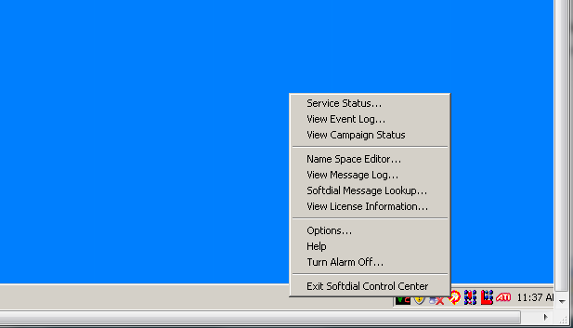

Click on the option ‘View License Information’ and take a screen print of the information displayed.

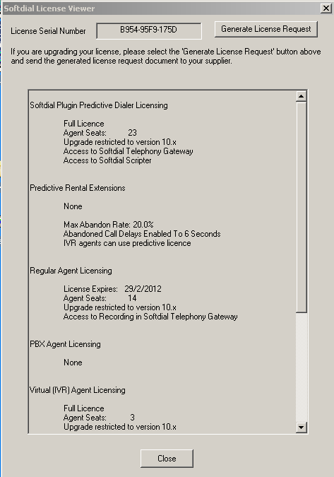

You will probably need to scroll down to make sure that all the license information is captured:

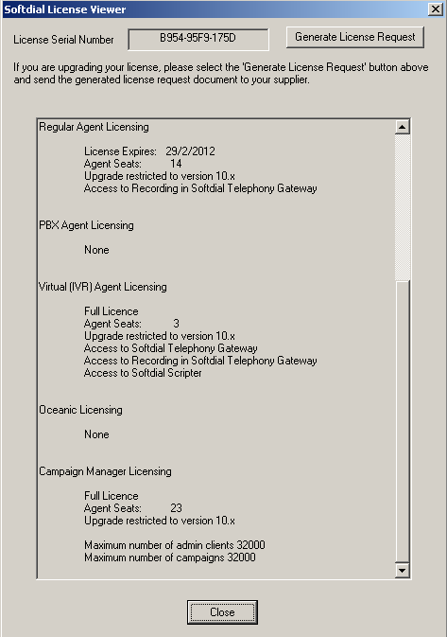

Send an e-mail to Quantrax Support requesting a new license permitting the abandon rate to be increased to 20%.

**Install your New License**

When your new license is ready, Quantrax will send it to you as an attachment to an e-mail. This attachment will normally be zipped. You need to place this attachment onto the desktop of your dialer server.

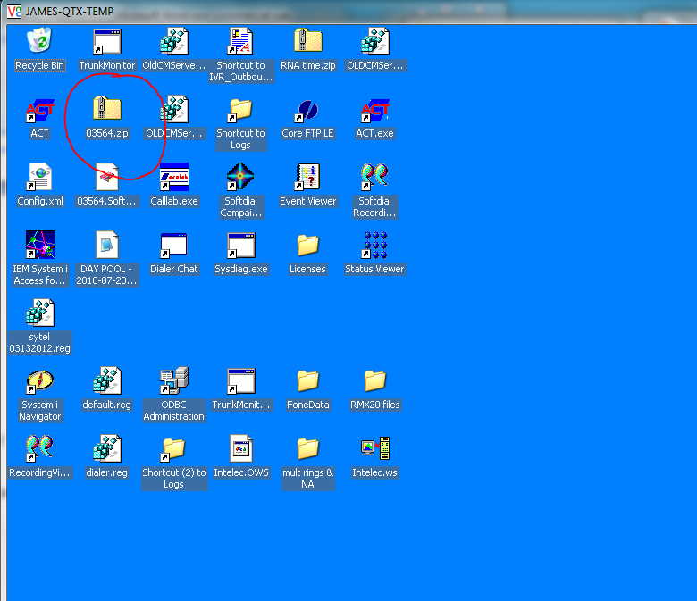

Double click on the zipped file to unzip it

The unzipped file will be displayed. Double click on this file to activate the license, and follow the instructions on the screen.

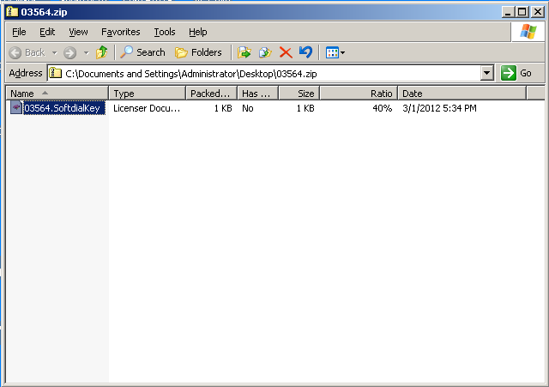

You will see a message notifying you that your license has been activated.

**Change the Tenant Configuration to ‘Collections’**

You must change the tenant configuration to ‘Collections’ to activate the 20% abandon rate for any campaign.

Click on the Softdial Control Centre at the bottom right of your dialer server:



Click on the option ‘Name Space Editor’.

Click on ‘Tenants, then double click on the ‘Tenant Configuration’

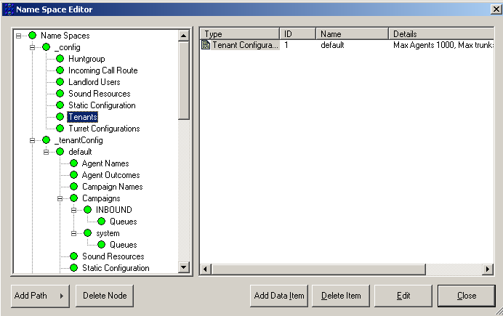

The Tenant Configuration Window will be displayed. In the bottom left, select the ‘Collections’ option and click OK.

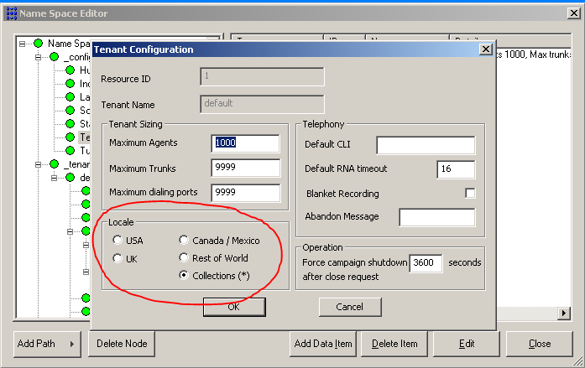

Close the Names Space window.

**Change the Abandon Rate for the Campaign**

Select the Campaign you wish to run at a 20% abandon rate, click on ‘Properties’ and then click on ‘Dialing Tuning’.

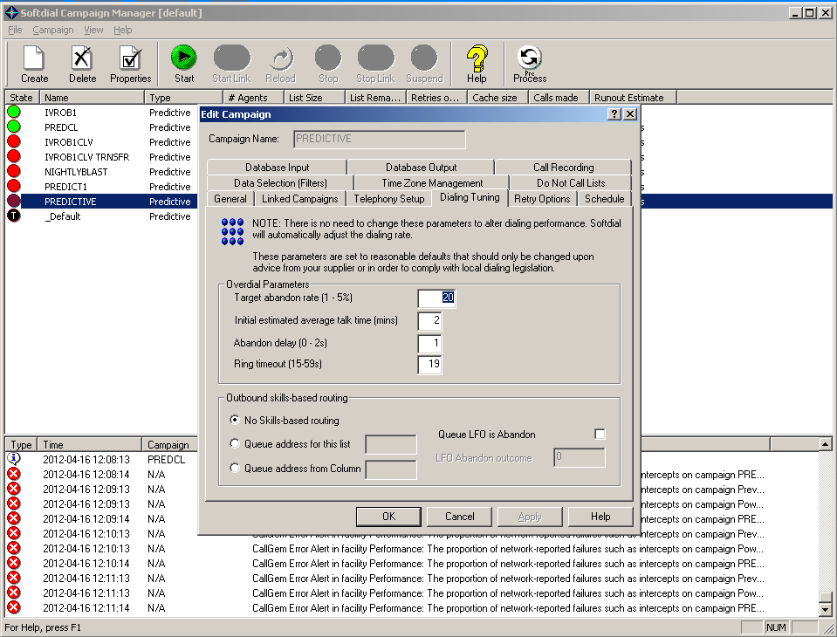

Change the value in the ‘Target abandon rate [1-5%]’ field to a value of your choosing. Note that the text for this field retains the ‘1-5%’ but you can enter any value up to 20. Enter any value from 1 to 20 and click ‘OK’. Your campaign will now run at the abandon rate you have specified. Note that this change can be applied while the campaign is running and it will take effect immediately.