**Softdial Console Guide**

*Updated on January 18, 2012.*

**Access the Browser Application**

* Open up Internet Explorer
* In the address bar enter: http://***<dialer address>***:80/scripter/default/BrowserApp.xbap

Note: you must have .Net Frameworks 3.5 SP2 or higher on your local machine to access this tool.

Note: If you have recently updated your Internet Explorer to version 9, you may have noticed that you are unable to load the Dialer Console.

If you are using Explorer 9 the following changes need to be made to the PC that you are trying to access the Dialer Console from.

* Open Internet Explorer.
* Go to Tools, internet options, security, custom level.
* Set ".Net Framework" to Enable.
* Set "XAML browser applications" to Enable.
* Click OK.

**Log In**

* Enter in your user name, password and extension. This is your user ID to access dialer applications. Your User ID must have supervisor authority or above to access the console. They must have configuration or above access to make changes.

***Note***: If you receive the error “Unauthorized Guest” and in the license monitor you get the message “Scripter license shortage. Unable to log on user.” You do not have the script license to access this console. Please contact Quantrax to receive correct licensing.

* This will bring up the “Select a campaign”.
* Select the Administrator campaign.
* It will ask you if you want to take calls: click “Yes”.
* The Softdial Console will now be loaded and the following screen will be displayed:

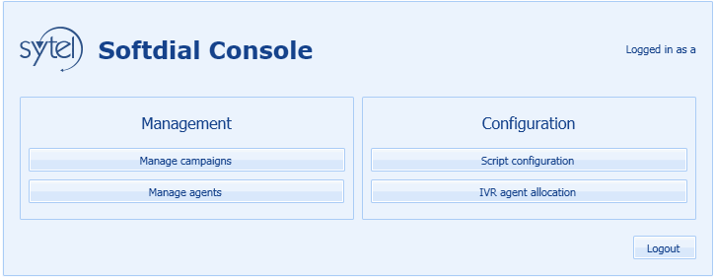

**Manage Campaigns**

This screen, similar to Campaign Manager, will allow you to start, stop and kill a campaign as well as display basic information regarding the campaign:

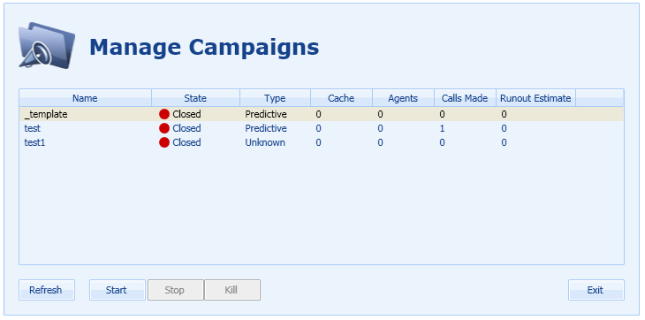

**Manage Agents**

This feature allows you to change an agent’s campaign or force the agent out of the dialer:

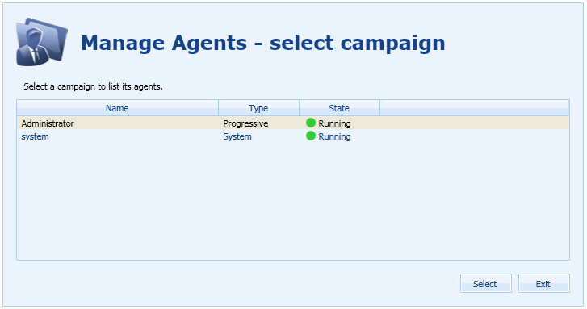

* This screen will show you all campaigns that are currently active.
* You can select the campaign for which you want to make changes to the agent activity.

Once a campaign is selected the following screen will appear:

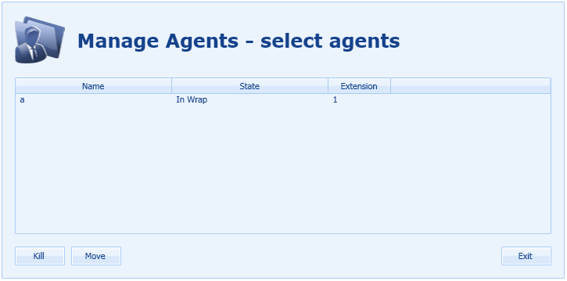

* This screen will allow you to select and agent and either move them to another campaign or the force them out of the dialer.
* If you select “Kill” a screen will appear to confirm your selection.

If “Move” is selected the following screen will appear:

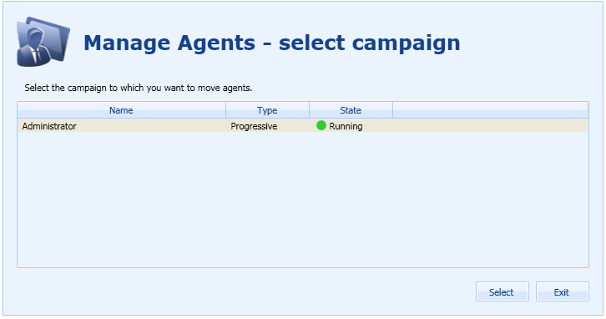

* You can only move an agent to an active campaign that is not the campaign the agent is currently in.
* Once you selected your campaign a screen will appear to confirm your selection.

**Script Configuration**

This screen will allow you to change or add the script that is to be associated to a campaign:

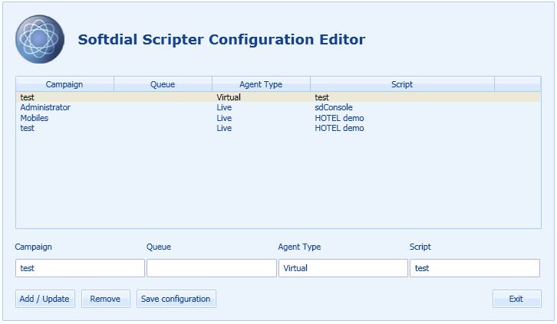

* Enter in the campaign name. (This is case sensitive.)
* Enter in the queues if you are setting up the virtual agents for inbounds only.
* Agent type should be Virtual for all IVR agents.
* Script names are provided to you when the scripts are created.
* If any changes are made, “Save configuration” must be selected for the changes to be stored.
* Please note that the changes will take place in real time.

**IVR Agent Allocation**

This screen allows you to add or remove additional IVR agents to a campaign:

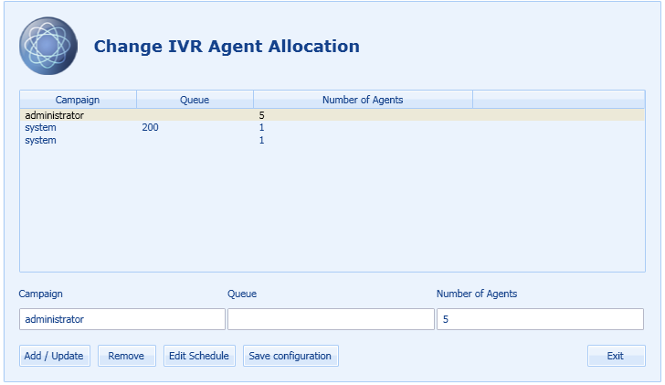

* Agents added using this method will have a random name and extension assigned to it. The name and extension will be “AutoVirtual_” followed by random assignment of characters.
* Agents added using this method will default to sign in only between the hours of 9am and 6pm. To modify this click on “Edit Schedule”, this will show a screen that allows you to modify the hours.
* If any changes are made, “Save configuration” must be selected for the changes to be stored.

NOTE: IVR agents added using the scheduler tool will not appear in this display.